**Goal:**

Allow for greater user input for volume threshold by letting user set volume threshold for each time of day. Also display the sound level that the device is receiving from the user in some visual or text based element.

**User Story Task Planning:**

As a user, I want to see how loud I am so that I can put the decibel values into perspective

* Grab the sound level data: 2 hours
* Create UI mockup for visual display of sound data: 3 hours
* Code UI for visual display of sound data: 5 hours

Total for above user story: 10 hours

As a user, I want to be able to preset daily schedules for the volume level thresholds so that I don’t have to set them before every activity.

* Receive time data: 3 hours
* Fetch appropriate volume threshold for time: 4 hours
* Create a settings page in the UI: 4 hours
* Create UI mockup for threshold scheduling: 3 hours
* Code UI for threshold scheduling: 5 hours

Total for above user story: 19 hours

**Roles:**

Abdullah Al-Omari: Developer

John Leckrone: Scrum Master, Developer

Akihiro Mizusawa: Developer

Jiying Qi: Product Owner, Developer

Vincent Thai: Developer

**Initial Task Assignment:**

Abdullah Al-Omari:

John Leckrone:

Akihiro Mizusawa:

Jiying Qi:

Vincent Thai:

**Initial burnup chart:** 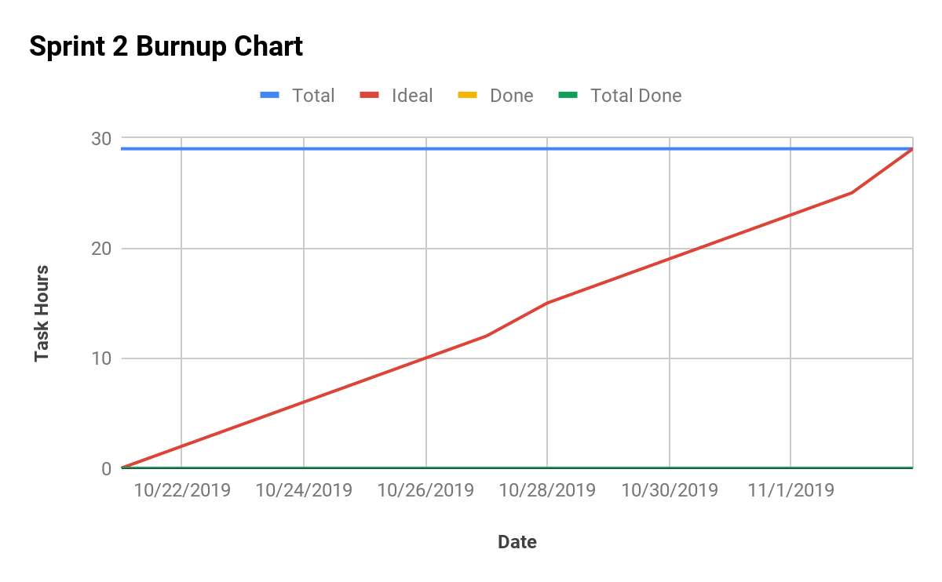

**Scrum times:**

Monday 6:00 - 6:30 PM with Scott Davis Baskin 302

Wednesday 6:00 - 6:30 PM Various Locations

Friday 6:00 - 6:30 PM Various Locations